FOR IMMEDIATE RELEASE
3 November 2021

PNB Merdeka Ventures Partners with Oakwood Premier to Open the First Serviced Residential Tower in Merdeka 118
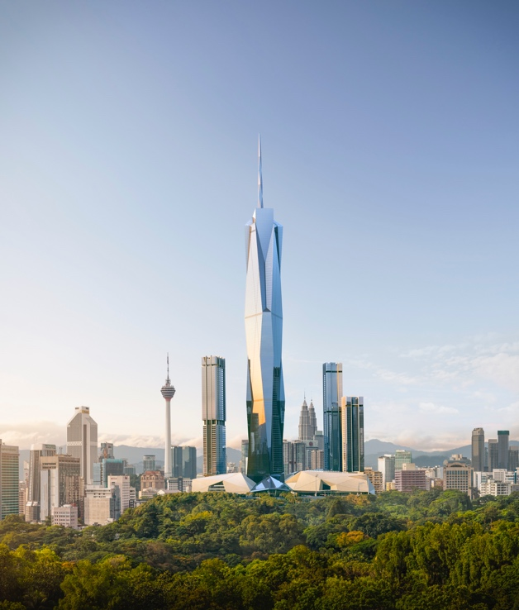
Oakwood Premier Kuala Lumpur to complement Merdeka 118 as a place to work, live and socialise
KUALA LUMPUR, 3 NOVEMBER 2021 – PNB Merdeka Ventures Sdn. Berhad (PMVSB), a wholly owned subsidiary of Permodalan Nasional Berhad (PNB), today announced the signing of a management agreement with Oakwood Premier Kuala Lumpur, to welcome an Oakwood Premier-branded residential tower to Kuala Lumpur’s iconic Merdeka 118 precinct. The Merdeka 118 tower stands adjacent to Stadium Merdeka, Malaysia’s historically significant landmark. The 118-storey tower is set to become the world’s second and Southeast Asia's tallest building at a height of at least 644 metres upon completion.
Oakwood Premier Kuala Lumpur will occupy one of the residential towers within the Merdeka 118 development featuring 348 serviced residences with one, two and three-bedroom categories. With spacious living spaces of up to 120 square metres in size, Oakwood Premier Kuala Lumpur will be able to provide comfort and security for both business and leisure residents.
PNB’s President & Group Chief Executive, Ahmad Zulqarnain Onn said, “Oakwood Premier is a leader in premium residential services and with this comes its signature hallmark of comfort and convenience. PNB is confident that the Oakwood Premier brand will enhance the appeal of the Merdeka 118 development.”
“Oakwood Premier Kuala Lumpur complements Merdeka 118’s mix of components, creating a desirable place to work, live and socialise in with fully activated, well thought out spaces for our visiting guests and resident community. We are delighted to welcome this celebrated brand of premium serviced residences to the Merdeka 118 precinct family,” said Ahmad Zulqarnain Onn.
Scheduled to open in December 2024, Oakwood Premier Kuala Lumpur will be the brand’s second property in the city, following Oakwood Hotel & Residence Kuala Lumpur. It joins a rapidly expanding portfolio of Oakwood Premier properties in Bangalore, Guangzhou, Hangzhou, Incheon, Jakarta, Melbourne, Phnom Penh, Singapore, Seoul and Tokyo with more in the pipeline.
“In Kuala Lumpur’s most prestigious new development, Oakwood Premier will deliver our distinctive brand of residential lifestyle for discerning guests who seek indulgence and style without compromising on hospitality excellence,” said Dean Schreiber, Chief Executive Officer of Oakwood. “Our inaugural partnership with PNB sets a new benchmark at the pinnacle of comfortable living for guests in Malaysia’s capital.”
In line with Oakwood’s renowned concept combining thoughtful amenities and guest services, Oakwood Premier Kuala Lumpur will offer peace of mind in a personal sanctuary. Proposed facilities include an all-day dining restaurant/bar, executive club lounge, residents’ lounge, meeting facilities, fitness centre, swimming pool and children’s playroom.
The Merdeka 118 development will breathe new life into downtown Kuala Lumpur and become a thriving core of commerce, culture and heritage. With the highest observation deck in Southeast
Asia, the first Park Hyatt Hotel in Malaysia occupying the top 17 floors of the tower, a retail mall surrounded by 4 acres of greenery and open spaces, as well as three premium residential towers encircling the Merdeka 118 tower, this mixed-use development is anticipated to attract business and leisure travellers from around the world. The Merdeka 118 tower overlooks two national historical landmarks – Stadium Merdeka and Stadium Negara.
The Merdeka 118 tower will be the first tower in Malaysia to achieve both local and international triple green platinum accreditations, namely the Green Building Index (GBI), Green Real Estate (GreenRE) and Leadership in Energy and Environmental Design (LEED).
For more information, please visit https://www.merdeka118.com or https://www.oakwood.com/.
Click here to download high-resolution images.
-END-
About Permodalan Nasional Berhad (PNB)
Permodalan Nasional Berhad (PNB) is one of the largest fund management companies in Malaysia with assets under management (AUM) exceeding RM300 billion. PNB's portfolio covers strategic investments in Malaysia's leading corporates, global equities, private investments and real estate. For more information, please visit www.pnb.com.my.
@pnbmy @PNBmy.Official Permodalan Nasional Berhad PNBmy

About PNB Merdeka Ventures Sdn. Berhad (PMVSB)
PNB Merdeka Ventures Sdn. Berhad (PMVSB) is a wholly owned subsidiary of PNB, as well as the builder and owner of Merdeka 118. PMVSB was incorporated in June 2000 and is the landowner and sole custodian of both Stadium Merdeka and Stadium Negara. Both stadiums have been listed as “National Heritage” sites in October 2005 under the National Heritage Act 2005. Thereafter PMVSB carried out meticulous conservation efforts, earning Stadium Merdeka the UNESCO Award of Excellence for Culture Heritage Conservation Programme (Asia Pacific) in 2008. For more information, please visit www.merdeka118.com.
@merdeka118 @merdeka_118 @precinct_118 Merdeka118

About Oakwood®
Oakwood®, a wholly owned subsidiary of Mapletree Investments, is a leading brand in hospitality management. A pioneer of the extended-stay segment, Oakwood manages a global portfolio of award-winning properties that combine the space and comfort of a private residence with the thoughtful services and amenities of a hotel, ideal for both short and extended stays. Through this specially crafted Oakwood experience that spans accommodation options comprising elegantly furnished serviced apartments, residential units and hotels, guests are invited to feel a sense of belonging, familiarity and reassurance whenever they stay at any Oakwood property around the world. For more information, please visit www.Oakwood.com.

Media Enquiries
- acorn communications: Natalia Ghani,
email: natalia@acornco.com.my I 012-231 4782
- Oakwood®: Ee Jin Lim, Head, Global Marketing;
email: eejin.lim@oakwood.com | 65.6885.1032;
Joleena Seah, Director – Southeast Asia, GHC Asia;
email: joleena.seah@ghcasia.com | 65.6715.1573

