COMMUNTIY GRANTS PROGRAMME
CYCLE 2

GENERAL APPLICATION FORM

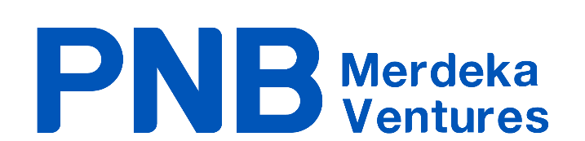

PROGRAMME OBJECTIVES

The Merdeka 118 precinct located within Downtown Kuala Lumpur is a project by PNB Merdeka Ventures Sdn. Bhd. (PMVSB). This new landmark development will create the much needed economic activation and vibrancy to the area.

PMVSB aims to provide support to our local communities within the Merdeka 118 precinct to re-configure your activities, create new content and provide opportunities for you to reset and restart - bounce back from any challenges you are currently facing and encourage self-sustainable approaches to build resilience towards future disruptions.

Applications are open to project proposals related to the development of community, education, sports, arts and heritage, and entrepreneurship activity within the Merdeka 118 precinct.

All members of the community with an impactful proposal are encouraged to apply!

These are the objectives of the community grants programme:
- To build a resilient community of improved health, social and economic well-being
- To inject new content into the surrounding area
- To encourage collaboration with surrounding communities
- To enhance the appeal of the area
- To showcase the history of the area

PART 1: APPLICANT DETAILS

- Name of Applicant (individual, organisation or institution) _____________________________________

- NRIC, ROS or registration number _______________________________________________________

- Primary Contact or Project Leader ________________________________________________________

- Contact Details:

Address: ____________________________________________________________________________
Tel. : _______________________________ Email : ________________________________________
Secondary email : _____________________________________
Website : _______________________________ Social media : _______________________________

PART 2: YOUR PROJECT

- Project Category
What category best describes the focus of your project? (Please tick one)

Sports – empowers communities and promotes participation, health and well-being
- Publications
- Exhibitions and talks
- Preservation of sports
- Space activation (events, festival, monthly competition)
- Capacity building workshops (coaching/training/educational seminars)
- Sports facility improvements/upgrades/enhancements
- Other, please specify: ___________________________

Arts – encourages incubation, collaboration and curation of creative content
- Community art programmes (exhibitions, art installation, murals, etc.)
- Innovative solutions incorporating technology (AR/VR, projection, light art)
- Preservation of traditional trades (publications, documentations)
- Capacity building and educational workshops for the arts community
- Other, please specify: ___________________________

Education – providing access to educational support for children and the youth through a wide-range of tools, resources and skills for learning
- Educational programmes
- Vocational training (carpentry, engineering, culinary, design, language courses)
- Literacy and numeracy programmes
- Problem-based learning
- Digital literacy courses (coding, website development)
- Educational spaces (libraries, tuition centres, makerspaces)
- Baseline entrepreneurial skills for start-ups
- Job seeking courses (for youth and those who have been furloughed due to pandemic)
- Other, please specify: ___________________________

Business Community – stimulates economic recovery
- Capacity building and entrepreneurial programmes
- Digitalisation of businesses
- Living heritage programmes for local cultural associations
- Vocational training for vulnerable communities (women, B40s, people with disabilities)
- Space activation (festivals, events)
- Other, please specify: ___________________________

- Project name: ________________________________________________________________________
____________________________________________________________________________________

- Project background: Please share a summary of what you plan to do.

(Limit: 1000 characters including spaces)

- Issues to address: What are the issues you want to address or what inspired this project?

(Limit: 1000 characters including spaces)

- Objective(s): What do you want to achieve from this project? Please list it clearly in point form
(Limit: 1000 characters including spaces)

- Which of these Sustainable Development Goals does your project address? (Please tick all that applies) [reference: https://sdgs.un.org/goals]
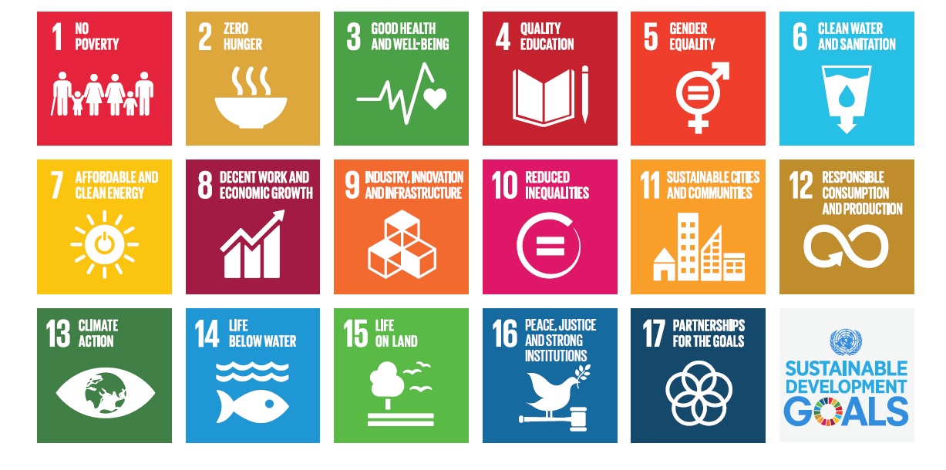
- Project start date: ____________________________________
- Project end date: _____________________________________
- Project duration: _____________________________________
*Project must be delivered within 12 months
- Target audience:

- Who are your target groups? (Please tick all that applies)
  - Creative and tech community
  - Cultural associations
  - Business community
  - NGOs, social enterprises, community associations
  - Traditional trades
  - Vulnerable communities (Women, People with Disabilities, B40s)
  - Sports institutions
  - Educational institutions
  - Religious institutions

- What is your target age group? (Please tick all that applies)
  - Under 12 years old
  - 12 – 17 years
  - 18 – 24 years
  - 25 – 34 years
  - 35 – 44 years
  - 45 – 54 years
  - 55 and above

- Please state the number of participants you plan to target
________________________________________________________________________________

- Please state your target male to female ratio
________________________________________________________________________________

- Please state the location(s) of your project
________________________________________________________________________________

- Output: What are the key deliverables and/or product of your project?

Proposed Milestone(s)  (tentative dates of key stages of the project) | Key Output(s)  (deliverables of each stage)
e.g.: 1 June 2022 | A workshop to meet with the arts group

- Methodology – What is your strategy or process to execute this project so that your timelines are met and your proposed output is delivered?
(Limit: 1000 characters including spaces)

- Expected outcome: short term (2-3 years) impact from the project. Key questions to ask yourself, how will this project affect the community, and the space? E.g., increased visitor appeal, increased co-investment, etc.
(Limit: 1000 characters including spaces)

- List of partners involved: (individuals, organisations or governmental bodies)

PART 3: PROJECT FINANCING

- Has this project received any grants from other government bodies or foundations?

Yes No

- If Yes, please list down details of the donor’s profile, the amount of funds received and what did the funds contribute to. (Limit: 1000 characters including spaces)

- Please state your total project cost, total secured funding and total funding required from PMVSB.
Total Project Cost (RM) | Total Secured Funding (RM) | Total Funding Required from PMVSB (RM)
*Please submit a budget breakdown using the budget template below

- Required documents to include in submission (in PDF format):

  - Applicant’s CV/profile/portfolio (for individuals/organisation)
  - Budget – a detailed breakdown of your costs, including any third party costing
(Please refer to the budget breakdown template at the end of this form)
  - Bank statement – a blanked out bank statement that shows bank account details and address
  - Company details – Form 9, 24, 44, 49, Memorandum and Article of Association
  - Registrar of Societies certificate (for societies only)
  - Other supporting documents: pictures, third party costings, research documents etc.

PART 4: DECLARATION BY GRANT APPLICANT

Conflict of Interest Declaration: I declare I have no perceived/pecuniary/direct conflict of interest to the application of this grant, Think City Sdn. Bhd. or PNB Merdeka Ventures Sdn. Bhd. If yes, please specify.

The information submitted in this application is true, to the best of my knowledge. Should any significant developments arise after this application is made, I shall notify Think City Sdn. Bhd. and PNB Merdeka Ventures Sdn. Bhd.

By submitting this form, I consent to the processing, collection, use and discourse of the personal data in this form by Think City Sdn. Bhd., PNB Merdeka Ventures Sdn. Bhd. and its related affiliates, in compliance with applicable data protection laws and regulations.

I consent to the information contained in this application form being held on computer and circulated to members of the Selection & Advisory Panel, other interested parties and the media in the spirit of accountability and open management.

I consent to allow PNB Merdeka Ventures Sdn. Bhd. the right to publish and document photos, information, research and any details pertaining to the above project.

Signature Date

……………………………………………………. …………………………………………………….
Name :
IC No :

DISCLAIMER
- All projects must comply to COVID-19 standard operating procedures
- For all publications, only the production cost is funded
- We do not fully fund any project/programme
- Projects must be completed within 12 months from time of grant award
- The grant does not cover:
  - Money spent prior grant approval
  - Political activities
  - Routine repairs and maintenance
  - Organisational overheads
  - Sales and Service Tax
BUDGET BREAKDOWN TEMPLATE

Please fill in the budget breakdown in the table below:
Item | Total Cost (RM) | Secured funding from other sources if any* (RM) | Total Cost needed from PMVSB (RM)
e.g., Professional Expertise

e.g., Logistics
e.g., Project Manager
Grand Total (RM)

*Please provide a letter of interest

